
GO-STANDARD NURSERY & PRI-SCHOOL
END OF YEAR EXAMINATION 2023
MIDDLE CLASS: (4 – 5 YEARS)
LEARNING AREA 2: LANGUAGE DEVELOPMENT I

My name is: …………………………………..………………………….
My School is: ……………………………..………….…………………..
I am in: ………………………………..………………………………………………..

- Circle the correct word.

bxo box xbo

sun snu nsu

bell blle ebll

dog dgo odg

mat tma mta

- Write the picture name.
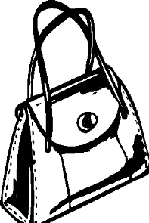

____________________



_____________________

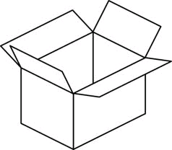

______________________

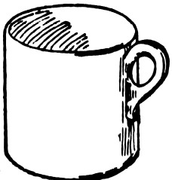

_______________________

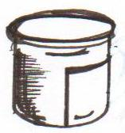

______________________

(bag, sun, tin, cup, box)

- Fill in the missing letters.
b ______ x,
p _____ t,
b ____ y,
d ____ g,
d ___, ___ r
- Match the same word.
bag one

bell bag

man mat

mat man

one bell
- Name the picture number.
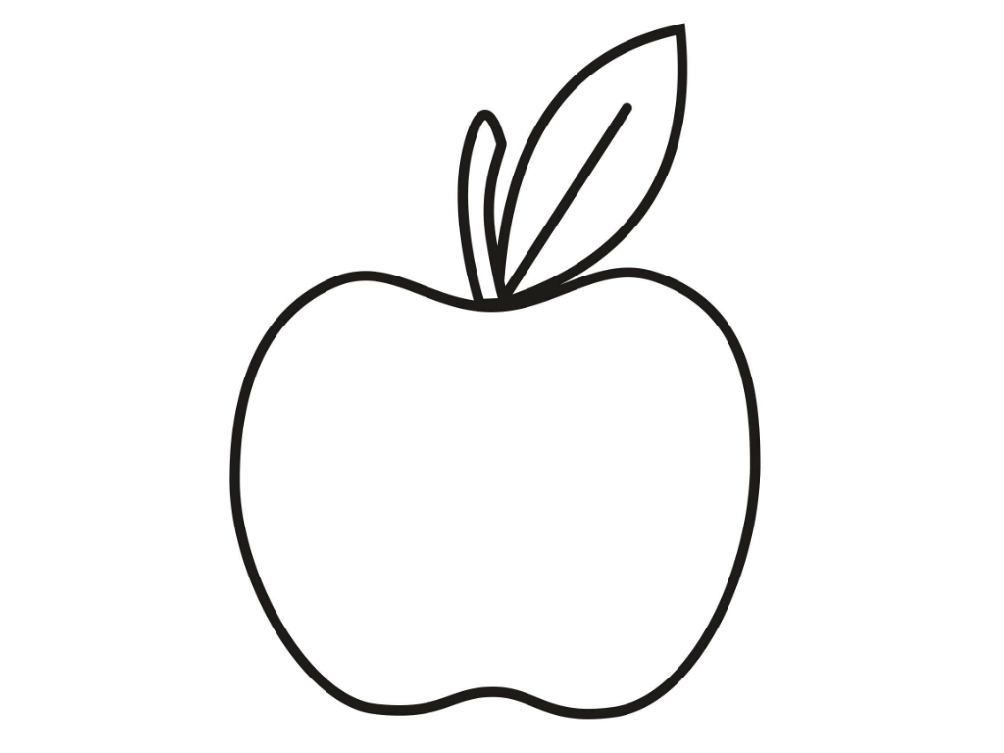
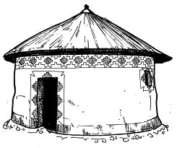

1 2 5

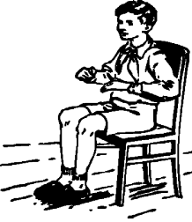
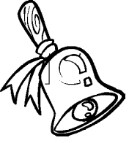
3 4

apple ________________________
hut ________________________
bell _________________________
boy ___________________________
cup __________________________

“Good Luck”

